Snowman Chocolate Bars
Fundraiser to support Camp Caritou
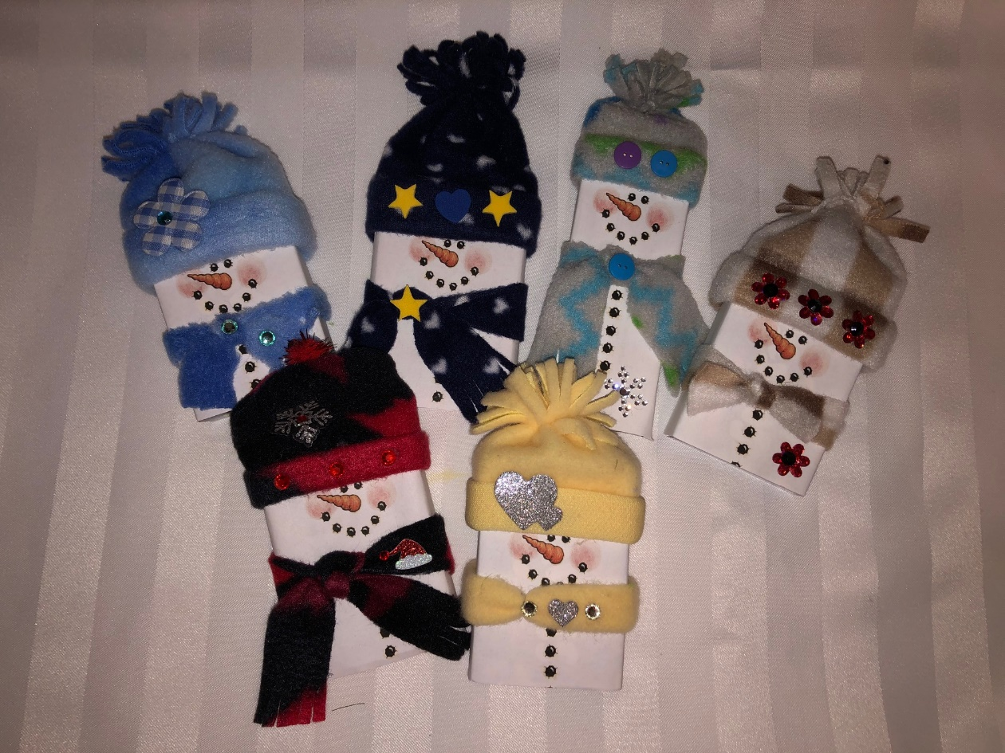
$3.00 ea or 2 / $5.00
Smarties, Aero, KitKat
or by contacting the Friends of Camp Caritou
friendsofcampcaritou@hotmail.com

