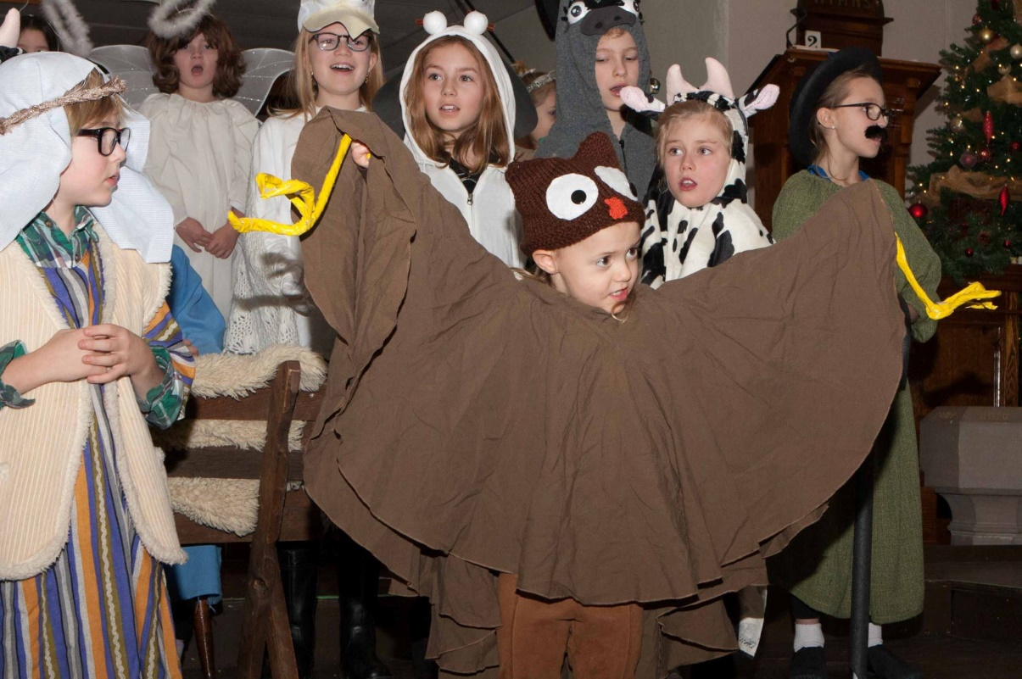

**TRINITY UNITED CHURCH**

**ADVENT 3**

**DECEMBER 16, 2018**

**CELEBRATION OF WORSHIP**

**December 16, 2018**

**THIRD SUNDAY IN ADVENT JOY**

**SUNDAY SCHOOL PAGEANT**

**\*** indicates to please stand as you are able

**Bold Print**  indicates a group response

**VU =** Voices United Hymnbook (Red cover)

**MV =**  More Voices Hymnbook (Spiral Bound)

**THOUGHT FOR THE DAY:**

"Joy does not simply happen to us. We have to choose joy and keep choosing it every day." ~ Henri Nouwen

**♫CAROL SING-A-LONG** 10:15am

**WE APPROACH GOD**

**\*♫OPENING HYMN:** “Rejoice, the Lord Is King” (VU 213)

**WELCOME & ANNOUNCEMENTS**

**LIGHTING THE ADVENT CANDLES**

As light colours the morning sky, birds raise their songs—greeting the coming day. *(The first two Advent candles are lit)*

Like that coloured sky, like those rising songs, these flames remind us of the growing light that announces the forever presence of Jesus.

*(The third candle is lit)*

**May we pause to hear that song—and join our voices to their joyful cries! Amen.**

**PRAYER OF CONFESSION**

God of this Advent season: On this Sunday when we light the Candle of Joy, we hold up to you the absence of joy in our lives. Forgive us when we fail to accept the gift of joy, when we fail to recognize joy, or share our joy generously…

*(A moment of silence for personal confession)*

“Those who wait on the Lord will renew their strength.” Allow God to answer our prayers, with forgiveness and with joy. Amen.

**ADVENT SUNG REFRAIN** (VU 954)

I waited, I waited on the Lord; I waited, I waited on the Lord;

Who bent down low, and remembered me, and who heard my prayer. ***(Repeat)***

**SUNDAY SCHOOL PAGEANT:**  “The Christmas Animals”

(by Troy and Genie Nilsson, Adapted by Lisa Blais)

* Carol: “Do You Hear What I Hear?”
* The Animals Gather
* Carol: “Jesus, Our Brother”
* Trio: “We Three Camels”
* “Angels We Have Heard on High”
* The Stable
* Carol: “Joy to the World” (VU 59)

**SCRIPTURE:** Zechariah 3: 14-20

Hear what the Spirit is saying to the church.

**Thanks be to God.**

**MEDITATION:** “Goofy God of Joy”

**\*♫HYMN:** “Joy Is Now in Every Place” (VU 45)

**WE CELEBRATE THE STORY**

**♫OFFERTORY ANTHEM:**

**\*♫PRESENTATION OF THE OFFERING** (VU 55)

What can I give him, poor as I am? If I were a shepherd, I would bring a lamb; if I were a wise man, I would do my part;

yet, what I can, I give him – give my heart.

**PRAYERS OF THE PEOPLE** (including the Lord’s Prayer)

Because we are going to be part of a new larger region in 2019 we are asked to pray for: Region 6 Staff (which includes

Susan Whitehead & Rev. Lillian Roberts from our congregation).

**WE GO OUT TO LIVE GOD’S STORY**

**\*♪CLOSING HYMN:** “Good Christian Friends, Rejoice” (VU 35)

**BLESSING**

**♪ CHORAL ENDING** (VU 1)

Rejoice! Rejoice! Emmanuel shall come to thee, O Israel

**♪ POSTLUDE:**

*Trinity United Church gathers on the traditional territory of the Anishinaabe peoples of Nipissing First Nations.  We*

*acknowledge with respect their history, their spiritual practices and their stewardship of this land.*

Thank-you to the Sunday School for sharing the Christmas story with us this morning! Thanks also to our Director (and very own miracle maker) Darlene Laferriere, as well as

Brenda McLay, our music accompanist; and Caroline Harrison, our costume coordinator.

Claudette and Natalya Brown would like to thank Rev. Ted and the Trinity church family for their prayers, cards and kindness on the death of “Willie,” Claudette’s brother. God bless.

Thank you, from Claudette.

Hymn lyrics reproduced with permission under license #610995©LicenSingonline.org.

***********************************************************************

**OUR LEADER TODAY IS:**

Laura Farris-Einarson

**OUR USHERS TODAY ARE:**

Bonnie-Rae Bailey,Cassie & Doug Bott-Baxter,

Chris & Gord Ford

**OUR CANDLE LIGHTERS ARE:**

Susan, Matthew, Julia & Andrew Whitehead

**WELCOME AND GOOD MORNING!**

Please join us downstairs after the service for coffee and conversation.

**2019 offering envelopes are ready for pick-up, please see Wanda after church this morning.**

**EMERGENCY EVACUATIONS AT TRINITY**

* In case of an emergency at Trinity, please know the location of your closest exit door—two at the front, two at the back. We are NOT allowed to use the elevator in the case of an emergency.
* Ushers, Teachers, and Choir members are trained to assist you (and the children) downstairs and outside to our emergency gathering location: The Capitol Centre Parking Lot.

**DID YOU KNOW?**

- Hearing devices and large print bulletins are available from the ushers. If you or someone you love would appreciate a visit from a Trinity friend or minister, please let us know via the office (705-474-3310) or a note in the offering plate.

**CHRISTMAS BOOKS** for pre-schoolers can be found in the back of the Sanctuary and also, on the top shelf of the middle section, of shelving next to the window in the Fireside Room.  These books can be borrowed indefinitely, or simply studied in the pews.

**TRINITY’S FOOD SHELF: Monday Mornings 9:30-11:00**

As we move into the colder times we will also be accepting clean, warm clothes such as sweaters, jackets, socks and mitts.

The **TREE OF HOPE** is exactly that.  The funds raised from this tree will go towards helping the children at a school that Hope2Kenya built in the Kibera slum of Nairobi.  What we provide gives the children Hope by providing a breakfast and lunch which for many are the only meals they receive in a day. We no longer do large fundraisers and are unable to give receipts so the funds raised by the tree are important to keeping Hope alive for many children.  Put $5.00 into the tin, take a card and turn on a light. Thanks for supporting this initiative.

**AOTS GIFT CARD FUNDRAISER-** **NEXT ORDER DATES** in 2019 are: January 13th, February 10th, March 3rd & 17th, April 7th.For further information please contact Ed Rose at 705-476-5316.

**TODAY**



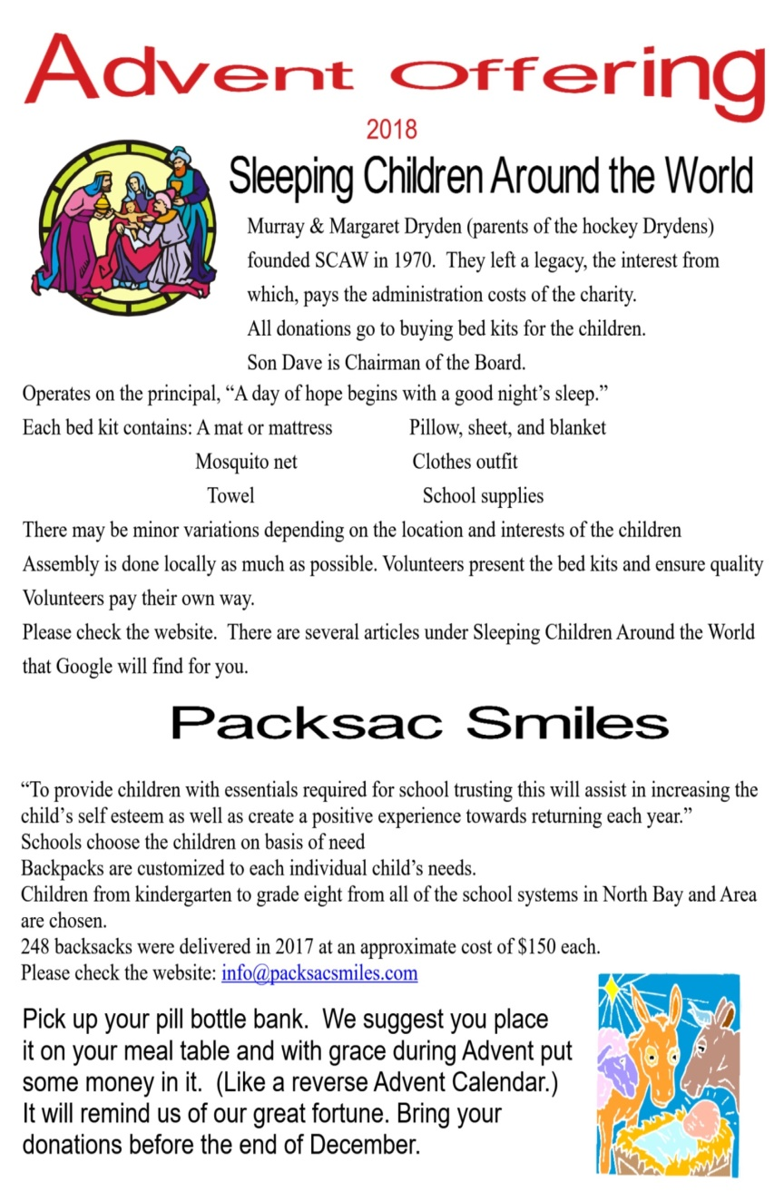

“To provide children with the essentials required for school, trusting that this will assist in increasing the child’s self-esteem as well as create a positive experience towards returning each year.”

Schools choose the children on basis of need.

Backpacks are customized to each individual child’s needs.

Children from kindergarten to grade eight from all of the school systems in North Bay and Area are chosen.

248 backpacks were delivered in 2017 at an approximate cost of $150 each.

For more information you can search Google for Packsac Smiles or visit [www.packsacsmiles.com](http://www.packsacsmiles.com)

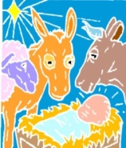**Pick up your pill bottle bank. We suggest you place it on your meal table and with grace during Advent put some money in it. (Like a reverse Advent Calendar.) It will remind us of our great fortune. Bring your donations before the end of December.**

