Trinity Families Winter Retreat
Saturday February 18th 1 pm – Monday February 20th 11 am
Spirit Point Wilderness Academy, Mink Lake Road, Trout Creek

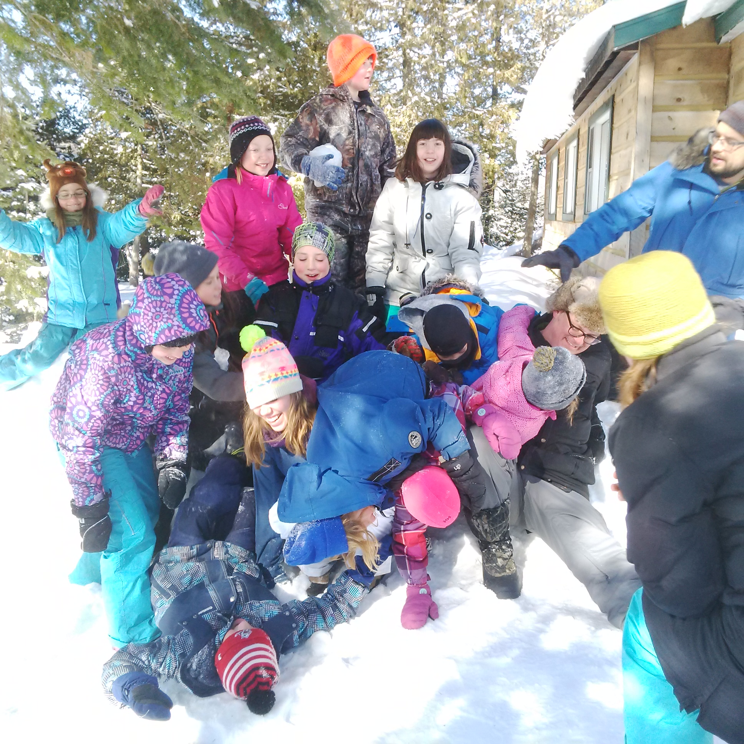

Join us at Spirit Point Wilderness Academy for a fun filled Family Day weekend! Outdoor games, skating, family worship, campfires, warm indoor activities and more!

Registration: $75 Adults and $50 per child (12 and under) for the first two children and then $25 per child for any additional children. Children under 3 are free. Room Rental: $25 per room (sleeps 4)

Registration deadline February 1, 2017. First come, first served – last year was sold out!

For more information and to register please contact Marcel MacDonald at glen_slim@hotmail.com or Lisa Blais at blais.trinity@gmail.com

Spirit Point is located on the northwest corner of Algonquin Park. www.spiritpoint.ca
Trinity Families Winter Retreat Registration

Family Name _______________________Number in group _____

Address: ___________________________________________________

_____________________________________________________________

Phone Number: ___________ Email:_________________________

Name | Adult or  Age of Child | Allergies/Food Restrictions/Special Needs

Registration: $75 Adults and $50 per child (12 and under) for the first two children and then $25 per child for any additional children. Children under 3 are free. Room Rental: $25 per room (sleeps 4)

Number of Adults ___________ Total Fee______________

Number of Children _________ Total Fee ______________

Number of Rooms __________ Total Fee ______________

Total Fee Paid __________

