**Trinity United Church**

**Advent and Christmas Services and Events**

**Advent Through Art 2015: Seeing the Season Through New Eyes**

For the seasons of Advent and Christmas 2015, we’ve asked our artists to help grant us new eyes. The art is on display downstairs in our Sunday School Hall. Each Sunday that art--along with scripture, drama, and song--will function as a touchstone, grounding us in the mystery and the challenge of this profound season of faith. Please join us for worship Sunday mornings at 10:30 am. A **Carol Sing-a-long** will happen each Sunday in Advent (except for December 13th) beginning at 10:15 am – Come and choose your favourite Christmas or Advent Carol to sing before worship.

**Sunday November 29th**  **Advent Communion Service, 10:30 am**

All people regardless of age or denomination are invited to receive communion. Communion is served early in the service while the Sunday School is present.

**Sunday December 6th – White Gift Sunday, 10:30 am**

Gifts of non-perishable food items, money, or other items that may bring comfort to those in need are gathered by the Sunday School children during the service. See the letter and list of needed items posted on the bulletin board in the Sunday School hall.

**Sunday December 13th - Cantata and Concerts**

The Senior Choir will present a **Christmas Cantata** ***“The Mystery and Majesty”*** at our morning worship service. Sunday December 13th at 10:30 am.

**The J.O.Y. Band and J.O.Y. Band *Too*** are presenting a **Christmas Concert** on Sunday December 13th at 2 pm. This is an afternoon the whole family will enjoy! Carol Sing-a-long starts at 1:30 pm. Good Will Offering with proceeds to Trinity Food Shelf and the North Bay Warming Centre. Complimentary refreshments will follow the concert.

**Wednesday December 16th**

**Trinity Arts present: A Reading of Dickens’ “A Christmas Carol” with seasonal music**

The classic tale of Scrooge’s rottenness and redemption propels us into the Christmas Spirit with style, humour, and timeless insight. A talented group of North Bay’s finest readers and musical performers will prepare you to encounter “the reason for the season.” Your ticket price supports “The Gathering Place.”

Join us at Trinity United Church (Ferguson at McIntyre) on Wednesday December 16th  for our 6:30pm sing-a-long of Christmas favourites, followed by the Dickens classic at 7pm.

Tickets are $15 (Children 12 and under are free)

Refreshments will be served after the show.

**Readers:** Josh Bainbridge, Tracey Berti, Rod Carley, Ted Harrison, Darlene Laferriere, Jennifer Ritchie, and Anthony Rota and **Musical Guests**: Baytones Harmony Chorus, Gateway Harmony and Heartbeat Barbershop Quartet.

**Sunday December 20th – Christmas Pageant Sunday, 10:30 am**

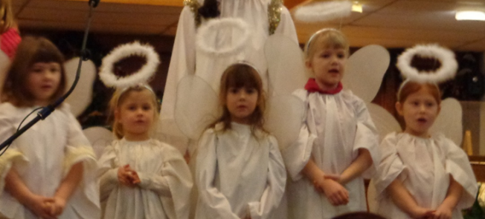Trinity’s Sunday School will perform “A Shepherd’s Tale” written by Brenda McLay and directed by Darlene Laferriere.

A cold potluck lunch will follow.

Rehearsals for the Christmas Pageant are held each Sunday during Sunday School beginning Sunday November 29th. A full dress rehearsal will be held Saturday December 19th at 9:30 – 10:30 am

**Monday December 21st Longest Night Service, 7:00 pm**

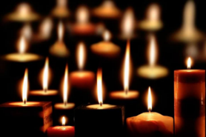“The Longest Night” is a worship service offered annually to the wider North Bay community by Trinity and St. Andrew’s United Churches. Accompanied by warm and contemplative string music, you are invited to light a candle and offer your deepest prayers as we acknowledge the pain, loneliness and fear that some of us struggle with during this time of the year.Come as you are to “The Longest Night,” December 21st at 7pm at Trinity United Church (Ferguson at McIntyre).



**Christmas Eve at Trinity – Thursday December 24th – 7 and 8:15 pm.**

Come early for a good seat to our 7pm Family Service. It will include a lively singing and telling of the Christmas story through scripture and music. Following the raucous Family Service, those who wish will re-gather in the sanctuary for a brief Christmas Communion Service at 8:15 pm. Your family and friends are welcome at both services!

**Sunday December 27th** – 10:30 am **Worship**

Join us for a relaxed service ….pajamas welcome.

**Sunday January 3rd –** 10:30 am **Epiphany Service**

**Sunday January 10th –** 10:30 am **Baptism Sunday**

**Friday January 22nd - The Trinity Annual Coffeehouse, 7pm**

Join folk from the North Bay Community for a night packed with lively entertainment and decadent desserts on Friday January 22nd at 7 pm. The Coffeehouse is a beloved new tradition of winter warmth that brings more and more remarkable local talent into the spotlight. All are welcome to offer their talent or to just come and enjoy the talent!

**The Subzero Superheroes – Coldest Night Team**

Members of Trinity United Church and the FIRST Robotics Team 1305, have joined forces once again to battle hunger in our community. On February 20th, the Subzero Superheroes will be joining caring folk from our community to raise money in support of our local soup kitchen, *the Gathering Place.*The gathering place serves a hot meal with warm hearts each weekday.   If you would like to join our team (or make a donation on behalf of our team) and help fight hunger in our community, please speak with Lisa Blais or Jim Liddell.