Trinity Events –May 2015

Join us for worship Sunday mornings at 10:30 am!

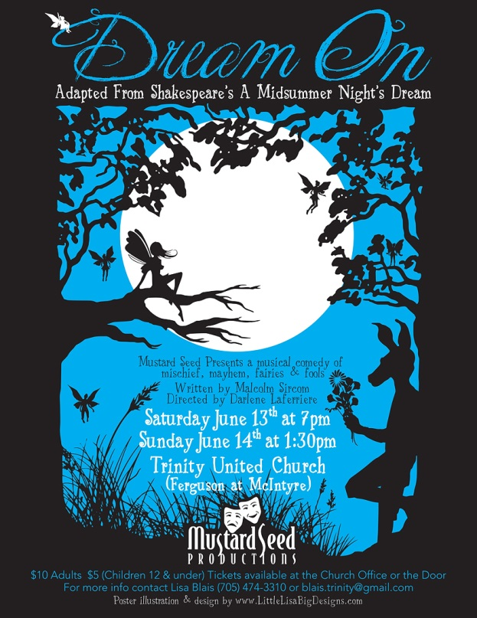

Mustard Seed presents a musical comedy of mischief, mayhem, fairies and fools!
Dream On is adapted from Shakespeare's Midsummer Night's Dream and is directed by Darlene Laferriere with musical direction by Brenda McLay.

Saturday June 13th at 7 pm and Sunday June 14th at 1:30 pm

Trinity United Church, North Bay (Ferguson at McIntyre)
$10 Adults $5 (Children 12 and under)

Tickets available at the Church Office or the Door

For more information please contact Lisa Blais (705)474-3310 or blais.trinity@gmail.com

Testosterone Warning!

The annual Men’s “Trinity Testosterone” canoe trip tradition continues in June of 2015! All men who are members or friends of Trinity are welcome to join up—but numbers are limited!

The Trinity Testosterone Trip of 2015 will take refuge in the northern wilderness between the evening of Friday June 26ththrough to the evening of Sunday June 28th. On May 31st, men who are interested in attending the Trinity Testosterone are invited to gather in Trinity’s Fireside Room to plan our route and various logistics. You don’t need to have a canoe or a canoe partner to sign up. Some space is still available.

May 2015 ● Trinity United Church ● (705) 474-3310

Upcoming Events
Sunday May 31st 10:30 am
Worship with The J.O.Y. Band!

Sunday May 31st 1:30 pm
Truth and Reconciliation walk Meet at St. Andrew’s United Church – All welcome!

Sunday June 7th 10:30 am
Anniversary of Church Union

Saturday June 13th 7:30 pm
Mustard Seed Presents:
Dream On - 7:30 pm
- Dessert reception to follow – free will donation to help purchase bells for the Joyful Bells

Sunday June 14th 10:30 am
Teacher Appreciation Day and Communion Service
(hotdog lunch to follow)

Mustard Seed Presents:
Dream On – 1:30 pm

Sunday June 21st 10:30 am
Father’s Day Baptism Service – contact the office ASAP if interested

Truth and Reconciliation Walk

On Sunday May 31st folk are invited to gather at St. Andrew’s United Church at 1:30 pm for a short worship gathering, followed by a walk down Main Street West to the Residential school Memorial on Nipissing Number 10. We are honoured to have the support and cooperation of Chief Marianna Couchie and the people of Nipissing First Nation for the walk. The total distance (one way is 5.2 kilometres). We plan on having vehicles waiting at the other end of the walk to ferry people back to St. Andrew’s once our time at the memorial concludes. It is a powerful witness to the pain of our collective past and an equally strong commitment to walking a better path in the future. (From Rev. Jane Howe, St. Andrew's United Church on behalf of the planning team)

Camp Lorrain 2015
July 1 - 18, 2015 C.I.T. Program (age 15-16)
July 5 - 11, 2015 Junior Camp (age 7-10)
July 12 - 18, 2015 Intermediate Camp (age 11-14)

For more information or to register visit www.camplorrain.com
Trinity’s Vacation Bible Camp
I SPY: MYSTERIES OF THE BIBLE
July 20th – 24th, 2015 9:30 – 3:30
$50 per child, includes camp t-shirt, lunch, snacks and all supplies. For children in Junior
Kindergarten – Grade 6 Children in Grade 7 and up are welcome to help out and gain valuable leadership skills. Highschool volunteer hours will be granted for those who qualify. For more information please contact Lisa Blais (705)474-3310 or by email blais.trinity@gmail.com

Registration is Now Open!

