***Trinity Families present***

**Red Hot Friday Night**

**Chili Cook-Off**

***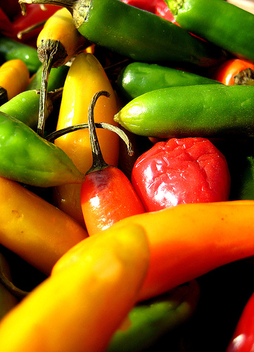*Live Musical Entertainment by Brian Risk,**

**The Heavenly Hosts and Friends!**

**Friday March 6th 5:30 – 7pm**

**Trinity United Church**

**All Welcome! Come on out and enjoy some delicious chili.**

**If you wish to submit a chili, sign up your team by calling (705)474-3310**

**Prizes for Fan Favourite, the most creative name, the best dressed chili, etc.**

**This year we will also have a *dessert* chili category!**