*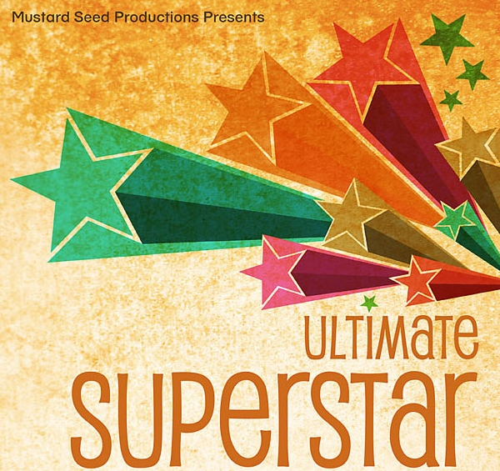***Friday February 28th and Saturday March 1st 7 pm.**

**Tickets $10 adults and $5 children.**

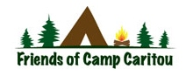 Friends of Camp Caritou

Pasta Dinner

**Saturday March 1st, 2014 5 pm – 7 pm**

**$10 Adults and $5 Children (12 & under)**

*Dinner and a Show*

*Why not make Saturday night an extra special evening? Come for pasta dinner and stay for the Ultimate Superstar Musical! C:\Users\Lisa\AppData\Local\Microsoft\Windows\Temporary Internet Files\Content.IE5\L3TLSNJ6\MC900112408[1].wmf*