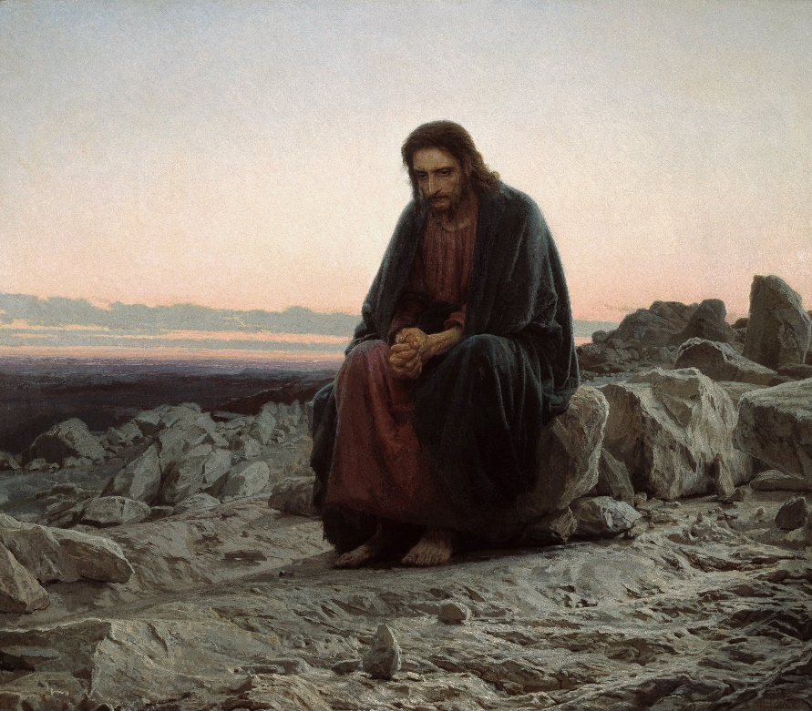

Trinity United Church
THE LENTEN BLUES
FIRST SUNDAY IN LENT, COMMUNION SUNDAY
Sunday, March 6th 2022

THE LENTEN BLUES
FIRST SUNDAY IN LENT, COMMUNION SUNDAY
Sunday, March 6th 2022

* indicates to please stand as you are able
Bold Print indicates a group response
VU = Voices United Hymnbook (Red cover)
MV = More Voices Hymnbook (Spiral Bound)
THOUGHT FOR THE DAY
“Here is the world. Beautiful and terrible things will happen. Don’t be afraid.” ~ Frederick Buechner

OPENING SEQUENCE: “Let Us Build a House” (MV 1)

PRELUDE

WE APPROACH GOD

WELCOME AND ANNOUNCEMENTS

CALL TO WORSHIP

People of God-- God calls you from the depths of your blues.
We are humble dust, we are precious gold.
Come before God in worship, be touched and transformed.
In so doing, we will build up our souls. Amen.

* ♪ OPENING HYMN: “O Love How Deep”
(VU 348, verses 1,2,3,7)

PRAYER OF CONFESSION:
God, we enter your presence confessing the things we try to conceal from you and the things we try to conceal from others. We confess the heartbreak, worry, and sorrow we have caused, that make it difficult for others to forgive us, the times we have made it easy for others to do wrong, the harm we have done that makes it hard for us to forgive ourselves. Have mercy, we pray...
(A pause for personal confession before the response)

ASSURANCE OF PARDON:
May we never take for granted all that we are given. May we never assume that God surrounds us with love because we have somehow earned it. Rather, it is God’s nature to bless, and we are creatures alive to the Spirit, made in God’s purposes. Accept that blessing-- and go forward in a forgiven faith. Amen.

THE SACRAMENT OF COMMUNION

INVITATION
We live in a world in which we often feel like strangers,
wandering from place to place, suffering,
unsure if we belong.
And then we come to the table-- to this mystery of bread and cup,
and we know ourselves to be at home, forgiven and loved!

God is with Us
We are not alone.
Christ is present here.
The Holy Spirit is among us.
Let us give thanks to God,
In memory and in hope.

♪CHOIR ANTHEM: “Come Find Forgiveness and Love”

Thanks and praise be to you, O God,
for you create life out of the dust,
and sustain us even in the desert wilderness.
In all our places of testing, you are present to direct and guide, to renew and revive.
You lead us on all our journeys and wilderness wanderings.
We praise you for sending us Jesus, your Suffering Servant,
to walk before us in the way of the cross,
to turn us to you and to one another,
and to give us bread for our life journey.
Therefore, we join your long procession of pilgrims praising you along the way:

♪ Sing: O holy, holy, holy God, (MV 203)
O God of time and space.
All earth and sea and sky above
bear witness to your grace.
Hosanna in the highest heav’n,
creation sings your praise.
And blessed is the One who comes and bears your name always!

As we gather at this table,
we remember that on the night before he died,
Jesus had supper with his friends.
He took bread, thanked you, broke the bread, and gave it to them saying:
“Take eat, this is my body, given for you.”
Then he took a cup, gave thanks to God and passed the cup to his friends saying:
“Take this and drink.
This is the sign of the new covenant poured forth for you and for the whole earth.”

By this bread and cup,
we remember Christ and share in the mystery of your being, and your suffering love.
Send your Holy Spirit, God, on us and what we do,
that we may know the miracle of bread and cup,
the miracle of your abundant love, and life for each of us and for all the earth.

♪ Sing: Sing Christ has died and Christ is risen, (MV 204)
Christ will come again! (x2)

THE FRACTURING & DISTRIBUTION:
Bread of Heaven, Cup of Sacrifice, Oil of Healing, Ashes of Repentance.

PRAYER AFTER COMMUNION
We give thanks that bread broken brings wholeness;
that wine poured out replenishes;
that time spend with the Risen Christ and one another is gift and grace. Amen.

♪ Sing: Amen, amen, O Holy One!
Hosanna and Amen! (repeat)

WE LISTEN FOR GOD’S STORY

SCRIPTURE READING: Luke 4:1-13
Hear what the Spirit is saying to the Church Thanks be to God.

♫HYMN: “Forty Days and Forty Nights” (VU #114)

MEDITATION: “The Vale of Soul-Making”

♫LENTEN BLUES: “Smiling Today” by Angie Nussey

WE CELEBRATE THE STORY

SUNDAY SCHOOL SINGERS: “Lord, Listen to Your Children Praying”

PRAYERS OF THE PEOPLE

THE LORD’S PRAYER (with the Trinity Sunday School)

WE GO OUT TO LIVE THE STORY

* ♫HYMN: “Amazing Grace” (VU 266)

GRATITUDES AND COMMISSIONING

SUNG BLESSING: “Sent Out in Jesus’ Name” (MV 212)

POSTLUDE AND IMPOSITION OF ASHES

During the postlude, you are welcome to proceed to the front of the aisles to be marked with the sign of the cross. Traditionally, the ashes are applied with the words, “Remember thou art dust, and unto dust you shall return” (from Genesis 3:19).

************************************************************************
Music and lyrics used in this service are either Public Domain or, if © copyright, they are covered by OneLicense # A-728080 or CCLI # 20878354

OUR LAY LEADER TODAY IS: Lisa Blais, Minister of Faith Formation and Outreach

Trinity United Church gathers on the traditional territory of the Anishinaabe peoples of Nipissing First Nations. We acknowledge with respect their history, their spiritual practices and their stewardship of this land.

Trinity United Church
www.trinitynorthbay.ca
111 McIntyre St. E. North Bay, P1B 1C5
705-474-3310
Email: trinitynorthbay@gmail. com
Follow us on Facebook
https://www.facebook.com/trinitynorthbay
Watch us on YouTube https://www.youtube.com/c/TrinityNorthBay
WELCOME AND GOOD MORNING
Please feel free to join us downstairs in the Fellowship Hall for friendly conversation. Coffee is on hold for now.

Groups and Activities are now resuming – including Sunday School. (The nursery is available by request but is not staffed at the moment). We are excited to welcome you back!

COVID PROTOCOLS UPDATE
Proof of vaccination is no longer required (but always encouraged). Please note that masks must be worn at all times and we encourage you to practice physical distancing and increased hand sanitization. Eating and drinking are not permitted unless prior permission has been granted.
A reminder that should you be experiencing symptoms of Covid or have been in contact with someone with Covid, we ask you to join us from home by attending our worship service on YouTube.

EMERGENCY EVACUATIONS AT TRINITY
In case of an emergency at Trinity, please know the location of your closest exit door—two at the front, two at the back. We are NOT allowed to use the elevator in the case of an emergency. Ushers & Teachers, are trained to assist you (and the children) downstairs and outside to our emergency gathering location: The Capitol Centre Parking Lot.

WHAT’S HAPPENING AT OUR CHURCH AND IN OUR COMMUNITY?

TODAY Sunday March 6 at 1 pm - we will hold our Annual Congregational Meeting on Zoom. All members and adherents of the church are encouraged to attend. There will be a proposed change to the by-laws and constitution. The draft constitution, by-laws and a summary, as well as the coordinates for the meeting were emailed out. If you did not receive this email please be in touch with Lisa at blais.trinity@gmail.com
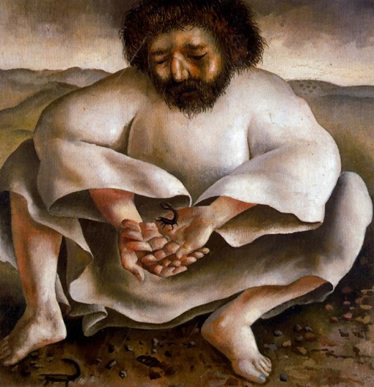

Art on today’s bulletin includes “Christ in the Wilderness” by Ivan Nikolaevich Kramskoy (1873) and “Christ in the Wilderness- the Scorpion” by Sir Stanley Spencer (1939)

