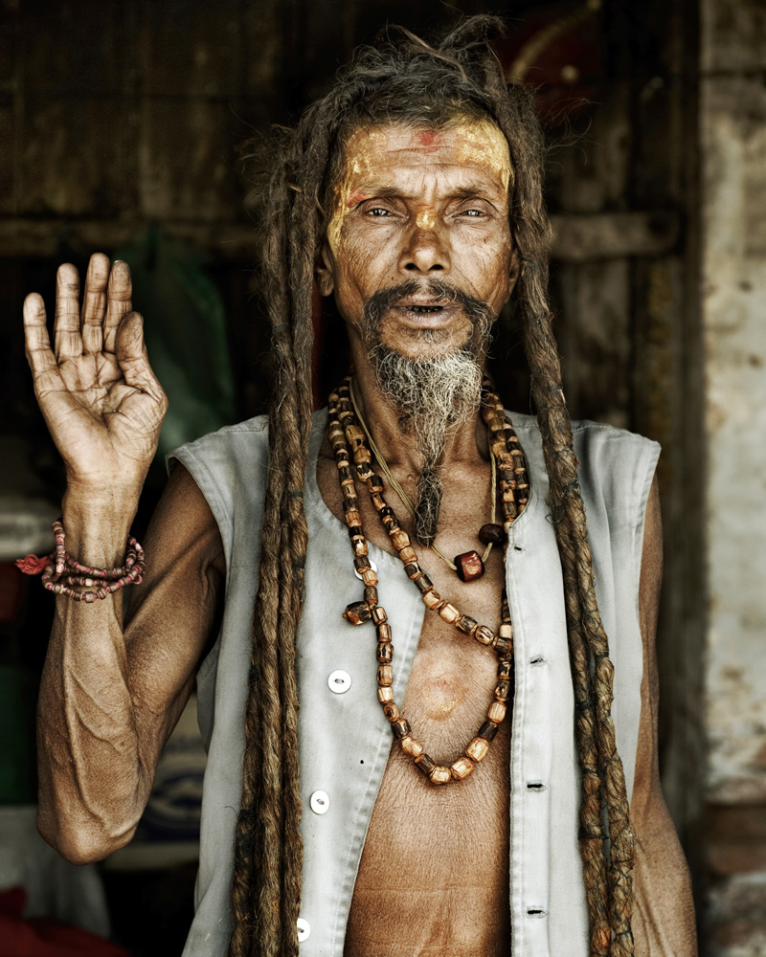

**TRINITY UNITED CHURCH**

**ADVENT TWO - PEACE**

**WHITE GIFT SUNDAY**

**ADVENT TWO - PEACE**

**WHITE GIFT SUNDAY**

**December 10, 2017**

**\*** indicates to please stand as you are able

**Bold Print**  indicates a group response

**VU =** Voices United Hymnbook (Red cover)

**MV =**  More Voices Hymnbook (Spiral Bound)

**THOUGHT FOR THE DAY:**

“Not all of us can do great things. But we can do small things with great love.” ~ Mother Teresa

**♪CAROL SING-A-LONG 10:15am**

**WE APPROACH GOD**

**\*♫ OPENING HYMN:** There’s a Voice in the Wilderness

(VU 18)

**WELCOME & ANNOUNCEMENTS**

Minute Persons: Betty Farris & Doug Bott-Baxter

**♫INTROIT:** Celebrate the Promise -J. Martin

**ADVENT 2 CANDLE-LIGHTING: ANGELS**

Last week, we lit a candle to remember the divine dreams shared by the Prophets of old.

*(The first Advent Candle is lit)* Now: Angels, what gift do you bring to us this Advent season? **We bring the gift of a message, a message of peace and joy, a message of a child born to help you see more clearly.** Thank you, angels, for your gift of a message.

*(The second Advent is lit.)*

**♪SUNG RESPONSE:**  **(**Tune: VU 62)

In the dark and cold of winter,

Light breaks in to calm our fears.

With the world we long for the season

When the Joy of God draws near.

Help us sing the faithful story

Of the joy that is your glory.

**WE LISTEN FOR GOD’S STORY**

**CHILDREN’S TIME:** *Gifts of non-perishable food items, or other items that may bring comfort to those in need are gathered by the Sunday School children.*

**♫SUNG LORD’S PRAYER** (VU 959)

**SCRIPTURE READING:** Luke 3: 1-18

Hear what the Spirit is saying to the Church.

***Thanks be to God.***

**♪*HYMN:** On Jordan’s Bank (VU 20)

**MEDITATION:** “One Hundred Miles Through the Desert”

**♪*HYMN:** I Am a Child of God (MV 157)

**WE CELEBRATE THE STORY**

**♪ OFFERTORY ANTHEM**: A Star Rising in the East -P.Chaplin

**\*♫ PRESENTATION OF THE OFFERING** (Tune: Wenceslas)

Here our gifts we offer, God, thankful for your blessings.

Take them, Spirit, use them to spread the peaceful Message.

That Christ comes to bring to us life for all creation.

May our gifts help bring to all love and transformation.

**PRAYERS OF THE PEOPLE**

**WE GO OUT TO LIVE THE STORY**

**♪*FINAL HYMN:** Hark the Glad Sound (VU 29)

**BLESSING**

**♪CHORAL ENDING**: (VU 1)

Rejoice! Rejoice!

Emmanuel shall come to thee, O Israel

**♪ POSTLUDE:**  A Christmas Medley

Hymn lyrics reproduced with permission under license

#610995©LicenSingonline.org.

Thank you to the following musicians for enriching our service today: Don Clysdale, Laura Farris-Einarson, Gord Hamden, Jennifer Hedican & Matthew Whitehead.

Sung refrain written by Rev. Andy O’Neill

Candle liturgy adapted from Susan Lukey.

Today’s offertory response written by Rev. Sandra Jenkinson.

*Trinity United Church gathers on the traditional territory of the Anishinaabe peoples of Nipissing First Nations.  We acknowledge with respect their history, their spiritual practices and their stewardship of this land.*

***********************************************************************

**OUR LEADER TODAY IS:**

Dave McKenney

**OUR USHERS TODAY ARE:**

Chris and Gord Ford, Wanda Gleason, Carolyn Crawford

**OUR CANDLE LIGHTERS ARE**:

Loriann & Trinity Mercier

**PLEASE** pick-up your containers in the kitchen from the cookie walk and bazaar.

♫ **CAROL SING:** Every Sunday during Advent10:15am

**2018 offering envelopes are ready for pick-up, please see Wanda after church this morning.**

**WELCOME AND GOOD MORNING!**

Please join us downstairs in the Fellowship Hall for coffee and fellowship following the service.

**EMERGENCY EVACUATIONS AT TRINITY**

* In case of an emergency at Trinity, please know the location of your closest exit door—two at the front, two at the back. We are NOT allowed to use the elevator in the case of an emergency.
* Ushers, Teachers, and Choir members are trained to assist you (and the children) downstairs and outside to our emergency gathering location: The Capitol Centre Parking Lot.

Youth (grade 7 and up) are invited to slow down and spend some time this season.

**FINDING BETHLEHEM IN THE MIDST OF BEDLAM**

Session 3- **Bedlam in Bethlehem (Games & Ornaments)**

Join us today for an Advent Bible. We will explore the Christmas story through readings, crafts, baking and more! Please bring a bagged lunch. For more information contact Lisa at [blais.trinity@gmail.com](mailto:blais.trinity@gmail.com) or 705-474-3310.

**AOTS GIFT CARD FUNDRAISER**

The last date for 2017 is **TODAY**. Your continuing support for this AOTS youth program is greatly appreciated.

**TODAY**

**THE J.O.Y. Band present “Sweet Sounds of Christmas”**

at Trinity. Carol Sing-A-Long 1:30pm. - Concert 2:00pm. Free Will offering will support the Synagogue Restoration Fund.

The **December** meeting of the **UCW** will be **TOMORROW** at Cecil's.  We will gather at 11:30. All ladies in the congregation are cordially invited to come for lunch, and a program of Christmas stories and poems.  Everyone will be responsible for buying their own meal. Instead of a gift exchange, please bring a donation for the Food Shelf.  Please let Judy know (705- 478 -7781) if you are able to join us.

**BUDGET MEETING**

Trinity’s board will meet on Tuesday, December 12th at 7:00pm in the Fireside Room. Please have your budget items ready for this meeting.

**FROM THE CHURCH LIBRARY**

Come rain or come shine by Jan Karon GR Kar

A new “Mitford” novel about Father Tim’s adopted veterinary son**.**

**ADVENT OFFERING PILL BOTTLE BANKS** will be distributed today-please pick one up at the back of the Church.

This time of year we all receive numerous solicitations to help fund worthy projects. For as long as our "old timers" can remember Trinity has offered another opportunity for your consideration through our Advent Offering. This is a once a year project that will go on for four weeks only. Our two projects this year will be: **SLEEPING CHILDREN AROUND THE WORLD (SCAW**) and **PACKSAC SMILES**

**♫ MUSIC MINISTRY AT TRINITY**

* **JOYFUL BELLS HANDBELL CHOIR** Tuesdays from 6 - 7:30pm in the Board Room.
* **SENIOR CHOIR** – Every Thursday at 7:15pm
* **JUNIOR CHOIR** practices every Sunday before church under the leadership of Peggy Millar. Children from JK to Grade 8 are **most** welcome.
* **TRINITY DRUM CIRCLE –** Is done until the New Year – look for information about a start-up date soon!

**CHEER PLATES**

This is the time of the year when we share goodies and visits with those who are unable to be out & about. On Thursday, December 21st at 9:00am the UCW will be packing and delivering “cheer plates”. We will need cookies and candy also, we need people to deliver. If you can help please call Rae Brownlee 705-472-2619.

**PORTRAIT PICK-UP-** Portraits and cards are available for pickup in Wanda's office. If you haven't had the chance to purchase your 8x10, they are printed and ready-to-go for $25.00. Thank you to all of the generous people who chose to increase or join **PAR**. We have raised over $1,000 and had 10 families join or increase **PAR** already! **BONUS**: If you've purchased cards or prints, Karen is willing to share your digital file with you. Email [KarenMJohnson@gmail.com](mailto:KarenMJohnson@gmail.com) with your name and she will send it to you.

If you were unable to get your photo taken please email Lisa a photo that you want in the directory. Thank you! **PLEASE NOTE: portraits from the last two photo sessions will not be ready until the new year.**

**Christmas Season is Coming**- When you are planning a meal out remember **SWISS CHALET** - keep your receipt and bring it to the Church as we receive 10% of all meals.

**TRINITY GAMES!** Come on out for a great evening of games – strategy games, board games, D&D, etc. Trinity Games nights happen on the second and fourth Friday of each month at 6:30 pm. This Friday is the last session before Christmas – we resume again on the second Friday in January. Enter through the McIntyre Street entrance. All are welcome. (Children under 15 must be accompanied by an adult)

**NEW YEARS COOL: A SILENT AUCTION DINNER**

Your “Trinity Arts” committee is hosting an exclusive New Year’s Eve Evening at the breath-taking Stenning Estate on the south shore of Lake Nipissing. Join us for a black-tie evening with a jazzy “Rat Pack” theme.

Featuring:

* Five-Plus course meal, dinner and drinks
* Black tie service and jazzy entertainment
* For up to eight guests (Minimum bid: $100 per plate)
* Proceeds to the Trinity “Cushy Tushie” Fund

Winners will be announced at the December 14th “Canadian Christmas” evening

* Alternative date: Saturday January 13th, 2018

**DATES AT A GLANCE**

* Thursday, December 14th - 7pm “A Canadian Christmas” (Sing-a-long begins at 6:30!).
* Sunday, December 17th 3rd Advent- 10:30am Sunday School. Christmas Pageant and 1:30pm Choir Cantata with the Joyful Bells and Junior Choir.
* Thursday, December 21st - 7pm Our “Longest Night” evening service.
* Sunday, December 24th 4th Advent– 10:30 am
* Christmas Eve Family Service, 7 pm followed by an 8:15pm Communion Service.

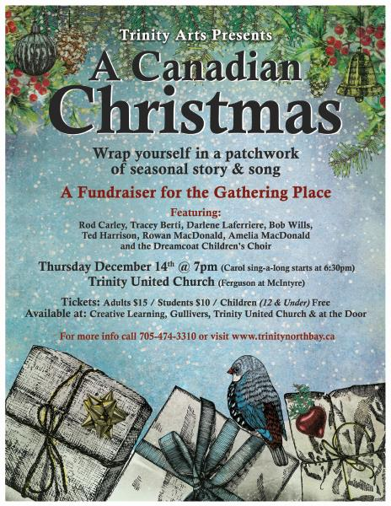



**TRINITY’S CHRISTMAS BAG OUTREACH PROJECT**

Each year the youth group collects items for Trinity’s *Christmas Bag Outreach Project*.  Last year we provided over 150 Christmas gifts to children, youth and adults in our community!

These bags are always warmly received and very much appreciated! If you would like to contribute to this project please bring any of the following items in to Trinity United Church on White Gift Sunday (December 10th) or to Lisa by Monday December 11th.

**Christmas gift bags and money for us to purchase the needed items are also appreciated.**

*For Men and Women*

* personal items: toothpaste, toothbrushes, lotion, shampoo, ***(please no hotel soaps – we have enough)***
* socks, slippers, mittens
* puzzle and word books, playing cards
* treats (candy, chips, chocolate, etc.) *\*\*\*please keep these separate from any soap products\*\*\**
* Diabetic/Sugar Free treats
* any other item that might provide comfort ( journals, gifts, books, mugs, etc.)

*For Youth* – *with an emphasis on* ***teens******and young adults***

* personal items: bubble bath, toothbrushes, soap, lotion, etc.
* socks, slippers, hats and mittens
* colouring and activity books
* videos, books or DVD’s
* games and craft items
* toys (no stuffed toys please)
* treats (as above)
* any other items that you think a youth might enjoy

**Thank-you for supporting this important outreach project**

**Wild Geese**

**You do not have to be good.  
You do not have to walk on your knees  
For a hundred miles through the desert, repenting.  
You only have to let the soft animal of your body  
love what it loves.**

**Tell me about despair, yours, and I will tell you mine.  
Meanwhile the world goes on.  
Meanwhile the sun and the clear pebbles of the rain  
are moving across the landscapes,  
over the prairies and the deep trees,  
the mountains and the rivers.  
Meanwhile the wild geese, high in the clean blue air,  
are heading home again.**

**Whoever you are, no matter how lonely,  
the world offers itself to your imagination,  
calls to you like the wild geese, harsh and exciting --  
over and over announcing your place  
in the family of things.**

**~ Mary Oliver (1986)**