Trinity Events – May 2013

Join us for worship Sunday mornings at 10:30 am!

We believe God is calling Trinity United Church to:
- reach out and serve the wider community and the world;
- to nurture spirituality in people of all ages;
- to be a safe, open, welcoming and inclusive community of faith.

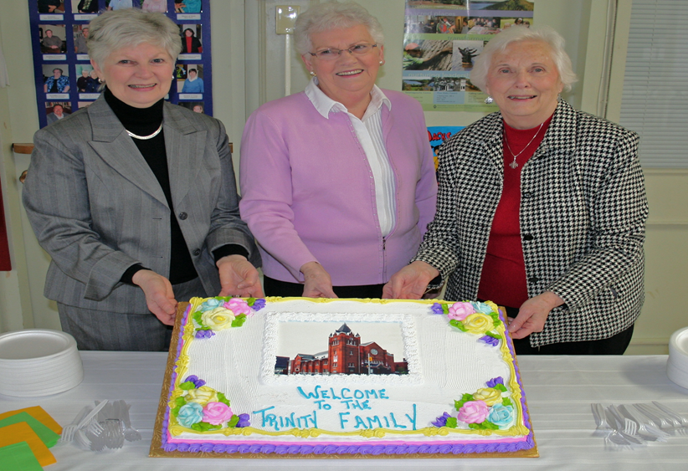

Sunday May 12th – Happy Mother’s Day!
Join us for a hymn sing at 10:15 am followed by a very special Mother’s Day Baptism Service.

Hope2Kenya Mother’s Day Luncheon (immediately following worship – 11:30 am) Free Will Offering - All are welcome! Kenyan Crafts will be for sale as well.

Sunday May 19th – Pentecost Sunday
Sunday School Children to share a musical offering

Sunday May 26th
Musical Offerings by the J.O.Y. Band during morning worship

Trinity Families Sponsored Lunch – Free will offering - All proceeds to Ione’s Garden

Right Relations Drum Presentation for Sunday School and Trinity Families to follow lunch This 45 minute presentation is open to all children, their families and anyone interested in learning (and playing) First Nations Drums.

Check out our website! www.trinitynorthbay.ca
Like us on Facebook! Trinity United Church North Bay

The Trinity Testosterone
MANITOU CONFERENCE General Meeting
“Midwives of the New Church”
God’s mission in the world has a Church—and that Church is undergoing birth pains which are not always welcomed. Join an excited and hopeful team of midwives for our Conference meeting—including Rob Dalgleish (the EDGE Network), Moderator Gary Paterson, and Musician extraordinaire Ron Klusmeier. Together we will marvel and prophesy, speculate and hope… as we prepare for the birth of the Church-yet-to-be! - Ted Harrison, President of Manitou Conference 2011-2013
Mindemoya, ON (on Manitoulin Island) from Friday May 31st – Sunday June 2nd, 2013.

Manitou Youth Forum “ReCreation”
Gather with United Church youth on the shores of Lake Manitou for retreat, renewal, and RE CREATION. Learn, connect ideas, practice your faith and shape our church today. Joined by Gary Paterson, Moderator of the United Church of Canada.

Visit www.manitouconference.ca for more information.

Trinity United Church
Cordially invites you to our annual
Glitter Gourmet Dinner Catered by Chef Donnie Blais
Friday May 24th
Entertainment 5:30 pm
Dinner served at 6:00 pm
Tickets: $40 per person ($25 tax receipt)
All Proceeds to Trinity’s Bricks and Gowns Fund
Buffet Style Gourmet Entrées
Dinner served in order of Ticket numbers – Get your tickets early! Available from the Church Office or from Doris Rae Brownlee. For more information call (705)474-3310
Menu Includes
* Salmon * Stuffed Chicken
* BBQ Steak * Salads * Pasta
* Decadent Desserts
*and much more!

All men are welcome to join the “Trinity Testosterone” men’s canoe weekend on the weekend of June 21st through 23rd. The trip will be limited in numbers, so sign up on the sheet available as of May 5th in the
downstairs Sunday School Hall. Participants will gather to plan details over coffee, after worship on May 12th. Please join us to plan details of the route, meals, and other important aspects of the trip!

Superheroes of the Bible! July 8 – 12th
$50 per child, includes camp t-shirt, lunch, snacks and all supplies. For children in Junior Kindergarten – Grade 6
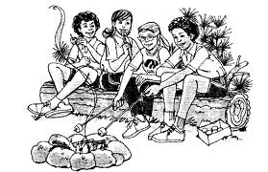
Children in Grade 7 and up are welcome to help out and gain valuable leadership skills. Highschool volunteer hours will be granted for those who qualify. For more information please contact Lisa Blais (705)474-3310 or by email blais.trinity@gmail.com

Camp Lorrain 2013
May 2013 ● Volume 1, Issue 3 ● Trinity United Church ● (705) 474-3310

Junior Camp (7- 10) ☼ July 14 – 20
Family Cap (All Ages) ☼ July 22 – 27
Intermediate 1 (11 – 14) ☼ August 4 – 11
Intermediate 2 (11 – 14) ☼ August 11 – 18
CIT (15 – 16) ☼July 9 – August 11
Women’s Retreat ☼ August 23 – 26
Discounts and Subsidies are available
Visit us online for more information, to register, or to donate: www.camplorrain.com

