Trinity Events – April 2013







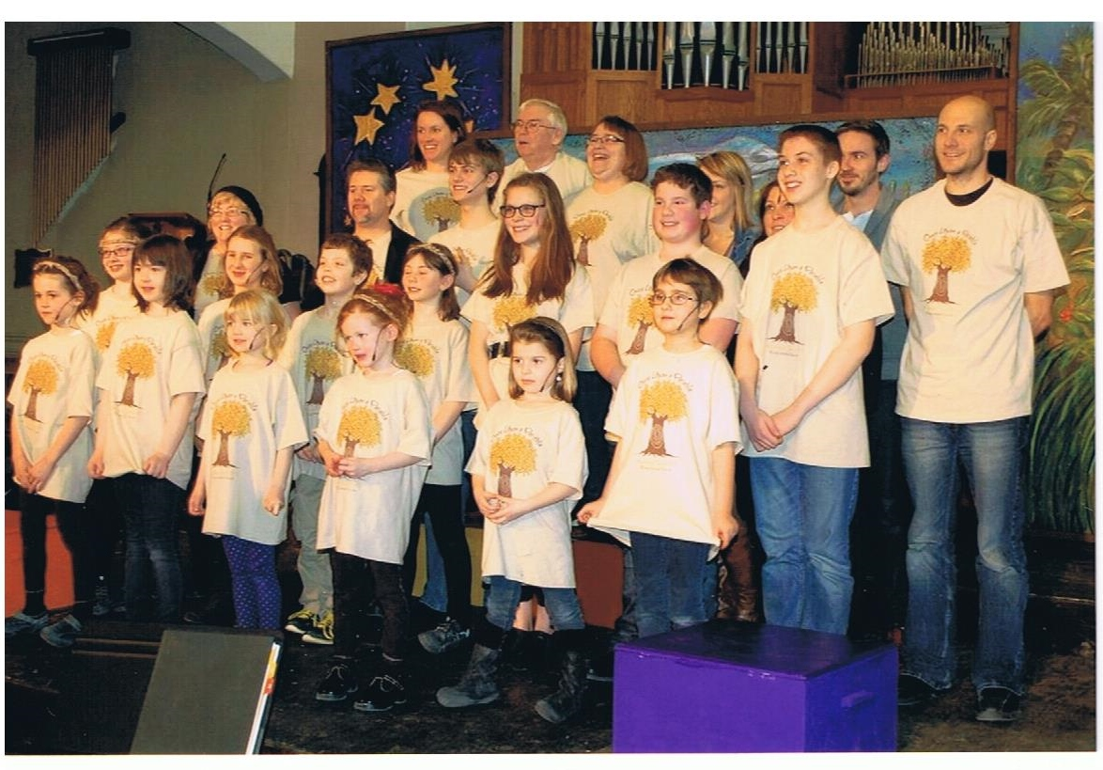

We believe God is calling Trinity United Church to:   
- reach out and serve the wider community and the world;   
- to nurture spirituality in people of all ages;   
- to be a safe, open, welcoming and inclusive community of faith.

The Cast and Crew of Mustard Seed’s Once Upon a Parable

**Holy Humour Sunday - Sunday, April 7th – 10:30 am**

This Sunday we celebrate Easter by sharing jokes. Bring your sense of humour and a good joke or two. Prayer Shawls will be blessed during the service.

**Sunday Worship, April 14th - 10:30 am**

A Free-Will Offering Lunch will follow the service

**UCW Cafeteria Style Luncheon - Friday April 26th 11 am – 1pm**

All are welcome!

**Saturday, April 20th – North Bay Presbytery**

All day at Trinity United Church. We welcome Susan Lindquist, Resource Relations Specialist, who will guide us as we explore the history of relationships with aboriginal people and vision ways to move forward.

**Earth Sunday April 21st – 10:30 am**

**Sunday Worship – April 28th – 10:30 am**

**I-DYG (Inter-Denominational Youth Group) – Sunday April 28th**

Our next meeting is Sunday April 28th and will be a trail/nature walk in Laurier Woods. Come on out and enjoy an invigorating walk and learn a thing or two about the flora and fauna in Laurier Woods. Bring a litter-less lunch and meet at the main entrance to Laurier Woods at 1 pm. For more info contact Lisa at [blais.trinity@gmail.com](mailto:blais.trinity@gmail.com)





**The Trinity Testosterone**

***Red Hot Friday Night***

***Chili Cook-off***

***April 12, 2013***

5:30 - Doors open  
6:00 - Chili Sampling and Judging  
7:15 – Awards

Teams or Individuals are invited to submit their original Chili recipe – This event is going to be "A Dinner With a Winner", yes, there will be a prize for the best Chili and Best Team Name (Chili themed)  
  
Free Will Offering suggested price

$10 Adults $5 children

**Heaven Hosts will play some red hot music!**

All men are welcome to join the “Trinity Testosterone” men’s canoe

weekend on the weekend of June 21st through 23rd. The trip will be

limited in numbers, so sign up on the sheet available in May in the

downstairs Sunday School Hall. Participants will gather to plan details

over coffee, after worship on May 12th. Please join us to plan details of the route, meals, and other important aspects of the trip!

**Superheroes of the Bible!**

***Coming this summer – July 8 – 12th***

$50 per child, includes camp t-shirt, lunch, snacks and all supplies. For children in Junior Kindergarten – Grade 6

Children in Grade 7 and up are welcome to help out and gain valuable leadership skills. Highschool volunteer hours will be granted for those who qualify. For more information please contact Lisa Blais (705)474-3310 or by email [blais.trinity@gmail.com](mailto:blais.trinity@gmail.com)



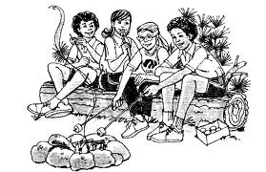



**Camp Lorrain 2013**

March 2013 ● Volume 1, Issue 2 ● Trinity United Church ● (705) 474-3310







Junior Camp (7- 10) ☼ July 14 – 20

Family Cap (All Ages)☼ July 22 – 27

Intermediate 1 (11 – 14)☼ Aug 4 – 11

Intermediate 2 (11 – 14)☼ Aug 11 – 18

CIT (15 – 16) ☼July 9 – August 11 Women’s Retreat ☼ August 23 – 26

*Discounts and Subsidies are available*

Visit us online for more information, to register, or to donate: [www.camplorrain.com](http://www.camplorrain.com)

☼☼☼☼☼☼☼☼☼

**Check out our website!** [**www.trinitynorthbay.ca**](http://www.trinitynorthbay.ca)

**Like us on Facebook!**

**Trinity United Church North Bay**

**Join us for worship Sunday mornings at 10:30 am!**